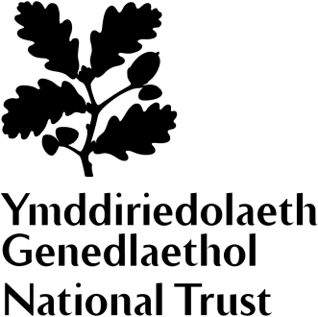
Dyffryn Gardens
Wildflower Survey Volunteer

A garden for all seasons
The Grade 1 listed gardens at Dyffryn are an exceptional example of Edwardian design. Covering more than 55 acres, they feature a stunning collection of intimate garden rooms, formal lawns and an extensive arboretum, home to one of the best woody collections in the National Trust. Designed by eminent landscape architect Thomas Mawson in 1906, the gardens are the early 20th century vision of coal magnate John Cory and his son Reginald.

A National Trust house with a difference
The Cory family were industrialists and made their wealth through coal. Dyffryn House, remodelled in 1893 from an earlier house, provided a secluded family home within commutable distance of their business interests across south Wales. The house came to the National Trust in 2013 without a collection. This has given us an opportunity to create something different. Several rooms are furnished, but with a twist – many things in the house can be touched and played with.

Role summary  When | Drawing on your love of wildlife, in this role you’ll be helping the gardens team survey flowers across the site to help us build a big picture of all our different habitats.  Wednesdays throughout the summer season
What's involved? | Working in small groups or independently to monitor wildflowers  Being a part of and learning about our work in habitat development  Recording and collating information  Learning to recognise different types of wildflower
This role will suit you if you are | - enthusiastic about nature  - methodical and thorough  - keen to get active outdoors  - happy to work independently  - knowledgeable or willing to learn about wildflowers
By getting involved you could | - Gain valuable outdoor experience with an internationally renowned conservation charity  - Join a dedicated team of like-minded individuals with a passion for wildlife  - Help us plan for future nature conservation work and habitat development

