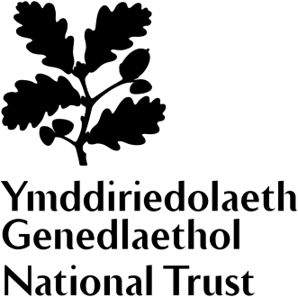
Dyffryn Gardens
Website Editor (MyVolunteering)

A garden for all seasons
The Grade 1 listed gardens at Dyffryn are an exceptional example of Edwardian design. Covering more than 55 acres, they feature a stunning collection of intimate garden rooms, formal lawns and an extensive arboretum, home to one of the best woody collections in the National Trust. Designed by eminent landscape architect Thomas Mawson in 1906, the gardens are the early 20th century vision of coal magnate John Cory and his son Reginald.

A National Trust house with a difference
The Cory family were industrialists and made their wealth through coal. Dyffryn House, remodelled in 1893 from an earlier house, provided a secluded family home within commutable distance of their business interests across south Wales. The house came to the National Trust in 2013 without a collection. This has given us an opportunity to create something different. Several rooms are furnished, but with a twist – many things in the house can be touched and played with.

Role summary  When | Do you understand what makes a website interesting and easy to navigate?  Would you like to help shape the content and future of Dyffryn’s pages on our internal volunteers’ website (MyVoluteering)?  Regular, flexible
What's involved? | Learning about the MyVolunteering system  Keeping the pages up to date  Liaising with staff and volunteers to seek out information  Taking volunteer feedback into account to create helpful and useful pages  Asking for and receiving support from both property staff and the National Trust central MyVolunteering team
This role will suit you if you are | Looking for a flexible volunteering opportunity and are happy to work independently – possibly from home  Creative with an eye for detail  Have good IT skills and are willing to be trained on a new system
By getting involved you could | Join a friendly and dedicated team, with opportunities to gain insight into different elements of the organisation.  Become the property lead on Dyffryn’s volunteering web pages  Build basic website knowledge  Use your creativity and IT skills  Make a lasting difference to volunteering at Dyffryn

