Society/Club Enquiry Form
Please read the FAQ document before sending this form to SUEvents@cardiff.ac.uk.
Remember this is an enquiry, your event is not booked until you’ve had confirmation from the events team!

Society Details
Society name: | Organiser 1 will be the first point of contact at the event.  Organiser 2 will be contacted if 1 is unavailable.
Name of organiser 1: | Phone Number: | Email:
Name of organiser 2: | Phone Number: | Email:

Event Details
Name of Event: |  | Preferred Date: |  | Expected numbers:
Has the Society/Club held this event before?  ☐ Yes  ☐ No |  | Access times:  Open:  Close: |  | Door Times:  Start:  Finish:
Guest Speaker(s):  ☐ Yes (please complete pages 2-3)  ☐ No |  | Catering required?  ☐ Yes  ☐ No |  | Bar required?  ☐ Yes  ☐ No
Who is this event for?  ☐ Society/Club members  ☐ Students  ☐ General public |  | Preferred venue(s):
 |  | ☐ Y Plas | ☐ Great Hall
 |  | ☐ The Lodge | ☐ Meeting Room(s) __________
 |  | ☐ Y Stiwdio | ☐ Other:____________________
Venue set up:
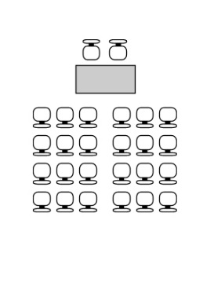  Theatre style ☐ | 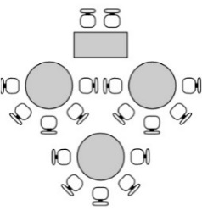  Cabaret style ☐ | Boardroom style ☐ |  |  |  | 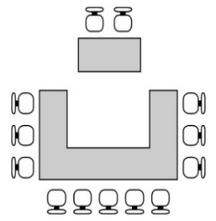  U-Shape style ☐
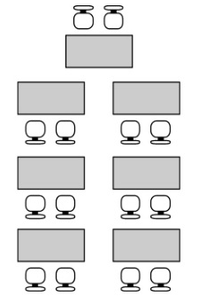  Classroom style ☐ | 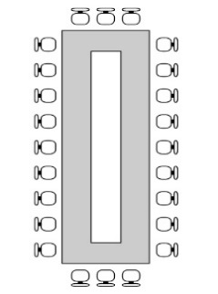  Banquet style ☐ | Other:  (Please give a full description of your requirements)
Catering: See a catering pack for other options. |  | Audio visual equipment: |  |  | ☐ Lectern
☐ Tea / Coffee | ☐ Sandwich platter | ☐ Lapel Microphone |  |  | ☐ Microphone & stand
☐ Water | ☐ Fruit bowl | ☐ Background music |  |  | ☐ Video Wall (Y Plas only)
☐ Packed Lunch  ☐ Biscuits | ☐ 6 item buffet | ☐ PA System |  |  | ☐ Projector & screen
Other requirements:
Please provide as much information as possible!

For office use only
Event Status: |  | Event Manager:
☐ Confirmed | ☐ Hold | ☐ Bar Staff booked
☐ Cancelled | ☐ Rescheduled | ☐ Catering pack sent

Guest Speaker Details
Any enquiry forms with a guest speaker must be submitted over 21 days in advance.

- Name of proposed speaker

- Date of birth

- Proposed speaker contact details
Phone
Email

- Is the speaker affiliated to any organisations?
If yes, please provide details

- Please provide details of the subject the speaker will present and any other information the University needs to be aware of

- Please provide a speaker biography (past events/locations, affiliations etc)

- Would you reasonably expect the speaker or the topic of discussion to attract any protests?

- Is there any information available that indicates that there have been issues raised with this speaker?

- Have there been issues at other venues in the past?
If yes, please provide details

- Is there information on open source research to the detriment of the speaker?
If yes, please provide details

- Has there been disruption at events that have involved the same topic in the past?
If yes, please provide details

- Has the speaker been refused permission to speak at other venues?
If yes, please provide details

- Is there a risk of the speaker’s attendance or subject of discussion (e.g. sex/gender, race, sexual orientation, disability) resulting in potentially raising an issue under the University’s equality policies?
If yes, please provide details
You will need to think about the potential for the subject matter or the speaker causing offence. This may include offence caused by criticism or negative language relating to an individual or groups based on their protected characteristic (e.g. gender, sexual orientation, ethnicity, age etc.) including any ‘jokes’ or ‘banter’. Think also would the speaker’s attendance in itself cause offence (because they are known for speaking publicly on topics that some individuals may find offensive). See the Dignity at Work and Study Policy for further guidance <http://www.cardiff.ac.uk/govrn/cocom/equalityanddiversity/dignityatwork/index.html>. You may want to provide copies of relevant equality policies to the speaker.
You will also need to think about the potential for the speaker/topic to be found to be ‘Inciting hatred’ or a risk of causing fear or alarm to attendees or the wider University community.
- Are there any identified security threats to the speaker?
If yes, please provide details
10. Does the speaker come with his/her own protective security detail?
If yes, please provide details

11. Are there any specific arrangements, requirements or restrictions relating to attendees that may result in equality issues being raised (e.g. gender segregated seating or attendance, alternative entrance for those requiring level access)?
If yes, please provide details

