Moving in Checklist

Before you move in:

 | Yes/No | QR Code
Is the landlord is registered with Rent Smart Wales?  All properties are required to be registered with Rent Smart Wales, by law, in order to protect tenants. |  | 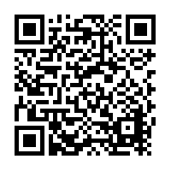
Have you been provided with a copy of your contract?  You should make sure you have this and keep it somewhere safe. |  | 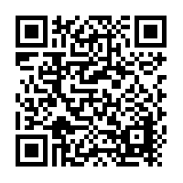
Has the landlord/agency has protected your deposit(s)?  All deposits are required to be protected by a Deposit Protection Scheme by law. |  | 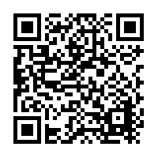
Does the property has an HMO License if it needs one?  Most shared student houses in Cardiff are deemed as Houses in Multiple Occupation (HMOs). |  | 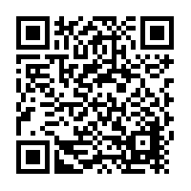
Have you been given a copy of the Gas Safety Certificate?  The landlord/agency are legally obliged to have an up to date gas safety certificate for the property and to give you a copy. |  | 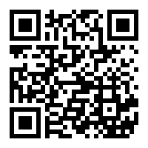
Have you arranged to collect your keys?  Landlords and agencies vary in their key collection protocol, so call ahead and check. |  | 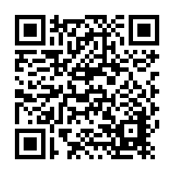

When you have your keys and are moving in:

 |  | QR Code
Take photos of everything.
Before you move any possessions in, take pictures of EVERYTHING and email them to the landlord/agent.
Record the electricity and gas meter readings as soon as you arrive.
Find the electricity meter and take a photograph of the number on there as soon as you can. If you have gas, do the same.

Check that everything’s working.  Make a list of all appliances that aren’t working and report them to the landlord/agent straight away. Check fridges, washing machines, microwaves, dishwashers and the boiler. |  | 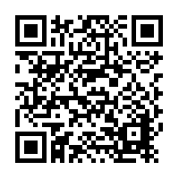
Check that fire alarms and carbon monoxide alarms are working.  This is a vital health and safety point which could save your life and so MUST be done. |  | 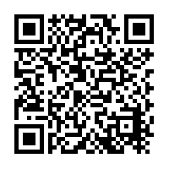
Check locks on all doors and windows.  Test all windows and doors to make sure they lock from the inside and can’t be easily broken from the outside. |  | 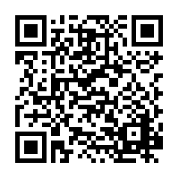
Organise a TV Licence.  You need it even to watch recorded programmes or streaming services such as BBC iPlayer online. |  | 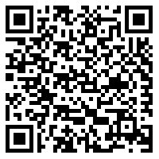
Sort out your bills  You will need to contact the utility providers and let them know you have moved in, set up an account and arrange a way to pay. This includes gas, electricity, water and wi-fi. |  | 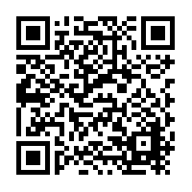
Register all housemates to vote.  Visit https://www.gov.uk/register-to-vote and follow through the registration process. It is the law to do so and your credit rating will improve. |  | 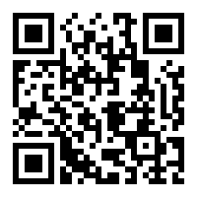
Get your Council Tax exemption certificate.
You can find a copy of your council tax exemption certificate on SIMS, via the ‘Council Tax Exemption Form’ button. It is your responsibility to contact Cardiff Council when you move in.
Change your registered address with the University and bank.
You can do this via SIMS by clicking ‘Update Address, Phone Number or Home Email’ to inform the University. You can find instructions to change your address with your bank via their website, by phone or in branch.
Find out which bins go out and when.  It is very important to follow the rules because, if you don't, Cardiff Council can and will fine you. |  | 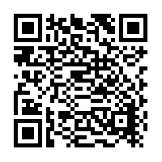
Register/update your address with a GP and dentist |  | 